**AI ASSISTED CODING ASSIGNMENT -02**

**NAME :** KARTHIK RAM . D

**HALL.NO :** 2403A52384

**BATCH.NO :** AI 14

**PROMPT 01 :**

I need a code fuction that reads a list of numbers and calculates the mean and maximum values

**CODE :**

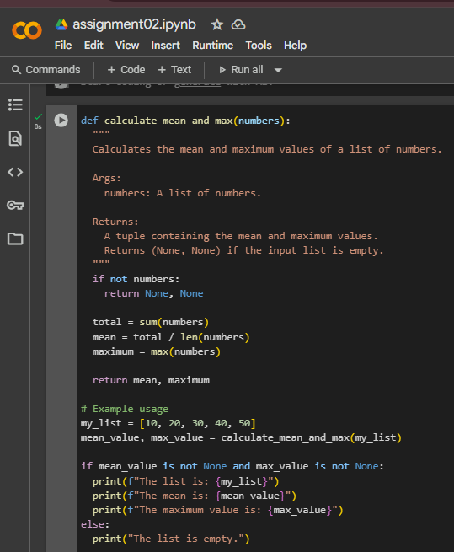

**OUTPUT:**

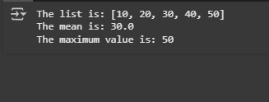

**CODE EXPLANATION:**

Function: calculate_mean_and_max(numbers)

1. Purpose: Calculates the *mean (average)* and *maximum* values from a list of numbers.
2. Empty list check: If the list is empty, returns (None, None).
3. Total calculation: Uses sum(numbers) to get the total of all elements.
4. Mean calculation: Divides the total by the number of elements (len(numbers)).
5. Max calculation: Finds the largest number in the list using max(numbers).
6. Return values: Returns both the mean and maximum as a tuple (mean, maximum).
7. Creates a sample list: my_list = [10,. Calls the function: mean_value, max_value = calculate_mean_and_max(my_list)`.
8. Checks if results are not None (list is not empty).
9. If values exist, prints:
   * The original list.
   * The mean value.
   * The maximum value.
10. If the list is empty, prints "The list is empty.".

**PROMPT 02 :**

I need python code ,function that checks wether a number is an amstrong number

**CODE :**

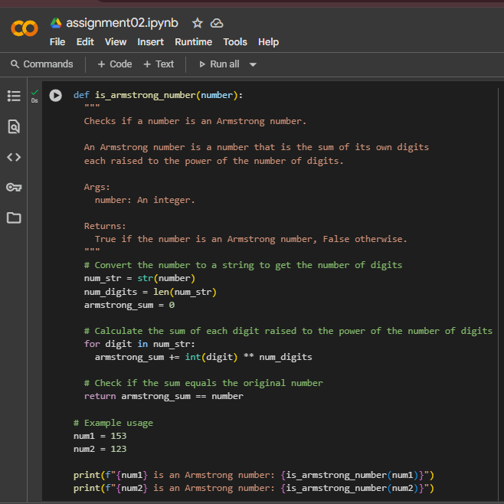

**OUTPUT :**

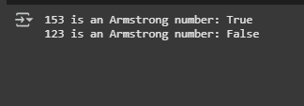

**CODE EXPLANATION :**

Function: is_armstrong_number(number)

1. Purpose: Checks if a number is an *Armstrong number*.
2. Convert to string: num_str = str(number) to handle digits easily.
3. Get digit count: num_digits = len(num_str) stores total digits.
4. Initialize sum: armstrong_sum = 0.
5. Loop through digits:
   * Convert each to int.
   * Raise to num_digits power.
   * Add to armstrong_sum.
6. Compare with original number:  
   return armstrong_sum == number → True if Armstrong, else False.

Example usage

1. Checks if 153 and 123 are Armstrong numbers using the function.
2. Prints results in format:  
   "XXX is an Armstrong number: True/False".

**PROMPT 03 :**

I need a python code , function check the number is prime number or a palindrome

**CODE :**

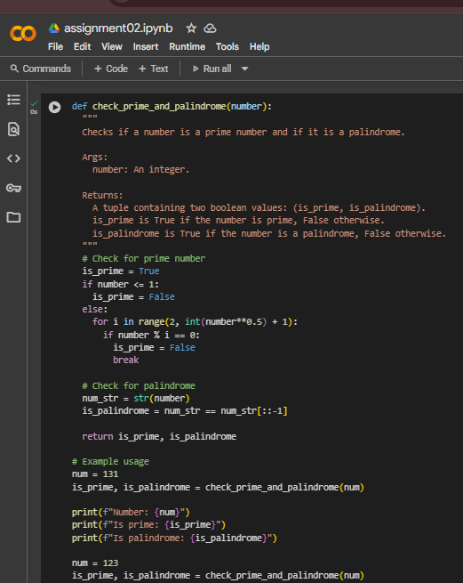

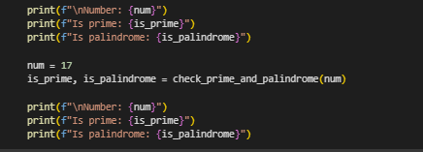

**OUTPUT :**

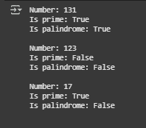

**CODE EXPLANATION :**

Function: check_prime_and_palindrome(number)

1. Purpose: Checks if a number is prime and if it is a palindrome.
2. Prime check:
   * If number ≤ 1 → Not prime.
   * Else → Check divisibility from 2 to √number.
   * If divisible → Not prime, else prime.
3. Palindrome check:
   * Convert number to string: num_str = str(number).
   * Compare with reversed string: num_str[::-1].
   * If equal → palindrome.
4. Return values:
   * (is_prime, is_palindrome) as a tuple of booleans.

Example usage

1. Test with numbers 131, 123, and 17.
2. Print:
   * The number.
   * Whether it’s prime.
   * Whether it’s a palindrome.

**PROMPT 04 :**

i need a pyhton code , function sum of the first N natural numbers and test the output



**CODE :**

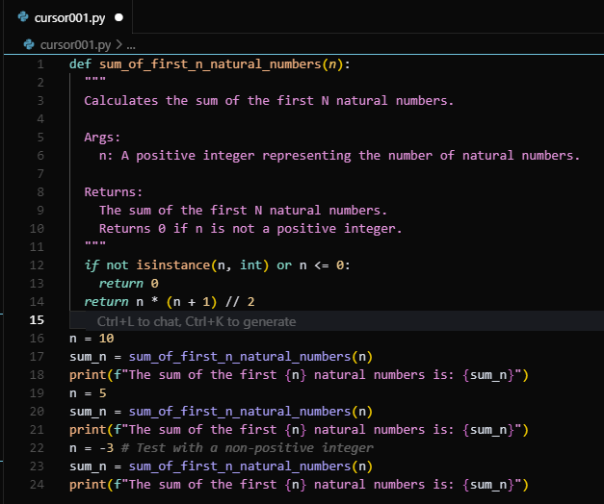

**OUTPUT :**

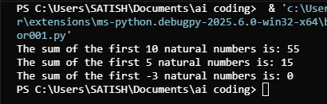

**CODE EXPLANATION :**

**Function Purpose**:  
Calculates the sum of the first n natural numbers using the mathematical formula:

Sum=n(n+1)2\text{Sum} = \frac{n(n+1)}{2}Sum=2n(n+1)​

**Input Validation**:  
Checks if the input n is a positive integer.

* If not, returns 0.

**Sum Calculation**:  
Uses integer division (//) to compute the sum efficiently without loops.

**Function Calls**:

* n = 10 → Prints the sum of first 10 natural numbers.
* n = 5 → Prints the sum of first 5 natural numbers.
* n = -3 → Invalid input, so it prints 0.

**Output**:  
Demonstrates how the function behaves for valid and invalid inputs.

**PROMPT 05 :**

i need a pyhton code , sum of even numbers and odd numbes

**CODE :**

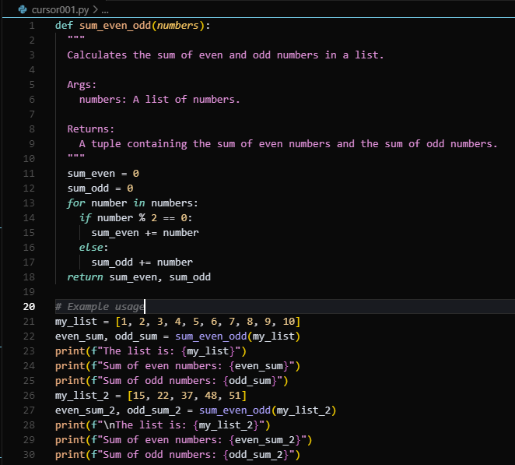

**OUTPUT :**

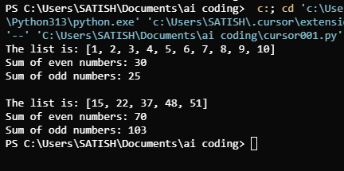

**CODE EXPLANATION :**

**Function Purpose**:  
Calculates and returns the sum of even and odd numbers from a given list.

**Parameters:**

* numbers: A list of integers.

**Initialization:**

* sum_even and sum_odd are both initialized to 0.

**Iteration and Condition:**

* For each number in the list:
  + If the number is even (number % 2 == 0), it's added to sum_even.
  + If the number is odd, it's added to sum_odd.

**Return Value:**  
Returns a tuple: (sum_even, sum_odd).

**Example Usage:**

* For my_list = [1, 2, 3, ..., 10]:
  + Even sum = 2 + 4 + 6 + 8 + 10 = 30
  + Odd sum = 1 + 3 + 5 + 7 + 9 = 25
* For my_list_2 = [15, 22, 37, 48, 51]:
  + Even sum = 22 + 48 = 70
  + Odd sum = 15 + 37 + 51 = 103

**Output:**  
Displays the original list and the respective even and odd sums.